**Domain Names System:**

The DNS resolves high-level human readable names for computers to low-level IP addresses

* DNS name space
* Domain Resource records
* Name servers
* **Domain Name space**

Because most people have trouble remembering the strings of numbers that make up IP addresses, and because IP addresses sometimes need to change, all servers on the Internet also have human-readable names, called domain names. For example, [www.howstuffworks.com](http://www.howstuffworks.com/) is a permanent, human-readable name. It is easier for most of us to remember www.howstuffworks.com than it is to remember 209.116.69.66.

The name www.howstuffworks.com actually has three parts:

1. The host name ("www")
2. The domain name ("howstuffworks")
3. The top-level domain name ("com")

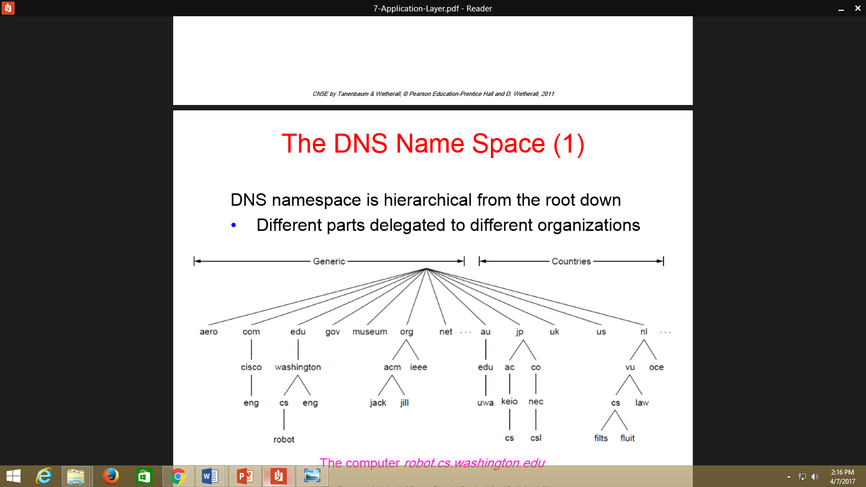

# Domain Resource Records:

# The key resource records in the name space are IP addresses and name servers, but there are others too.

# 

# Name Servers

A set of servers called [domain name servers](http://computer.howstuffworks.com/dns.htm) (DNS) maps the human-readable names to the IP addresses. These servers are simple databases that map names to IP addresses, and they are distributed all over the Internet.

Most individual companies, ISPs and universities maintain small name servers to map host names to IP addresses.

Finding the IP address for a given hostname is called resolution and is done with the DNS protocol.

Resolution:

• Computer requests local name server to resolve

• Local name server asks the root name server

• Root returns the name server for a lower zone

• Continue down zones until name server can answer

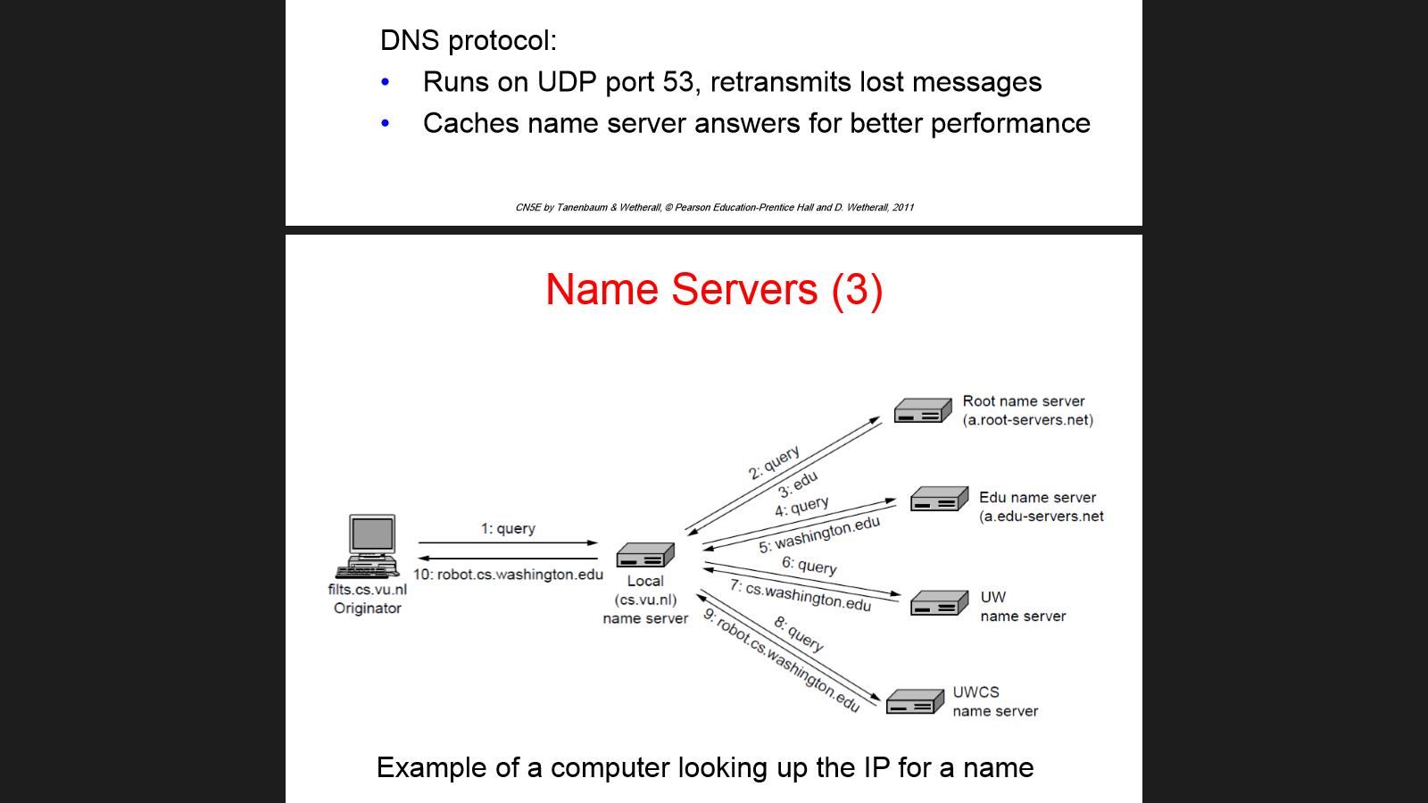

**Electronic Mail**

• Architecture and services

• The user agent

• Message formats

• Message transfer

• Final delivery

**• Architecture and services**

**Electronic mail, or email, is a method of exchanging digital messages between people using digital devices such as computers and mobile phones.** Email operates across [computer networks](https://en.wikipedia.org/wiki/Computer_network), which today is primarily the [Internet](https://en.wikipedia.org/wiki/Internet). Some early email systems required the author and the recipient to both be [online](https://en.wikipedia.org/wiki/Online_and_offline) at the same time, in common with [instant messaging](https://en.wikipedia.org/wiki/Instant_messaging). **Today's email systems are based on a**[**store-and-forward**](https://en.wikipedia.org/wiki/Store-and-forward)**model**. Email [servers](https://en.wikipedia.org/wiki/Server_(computing)) accept, forward, deliver, and store messages. Neither the users nor their computers are required to be online simultaneously; they need to connect only briefly, typically to a [mail server](https://en.wikipedia.org/wiki/Message_transfer_agent) or a [webmail](https://en.wikipedia.org/wiki/Webmail) interface, for as long as it takes to send or receive messages.

# 

# User Agent: it is the computer program that manages and access the user email..

# 

# Sample Message Formats:[RFC 5322,RFC 2045.RC 2049]

The Internet email message format is now defined by [**RFC 5322**](https://tools.ietf.org/html/rfc5322)**,** with **multimedia content attachments** being defined in [RFC 2045](https://tools.ietf.org/html/rfc2045) through [RFC 2049](https://tools.ietf.org/html/rfc2049), collectively called [***Multipurpose Internet Mail Extensions***](https://en.wikipedia.org/wiki/Multipurpose_Internet_Mail_Extensions)**or *MIME*.**

Internet email messages consist of two major sections, the message header and the message body. The header is structured into [fields](https://en.wikipedia.org/wiki/Field_(computer_science)) such as From, To, CC, Subject, Date, and other information about the email**. In the process of transporting email messages between systems, SMTP communicates delivery parameters and information using message header fields.** The body contains the message, as unstructured text, sometimes containing a [signature block](https://en.wikipedia.org/wiki/Signature_block) at the end. The header is separated from the body by a blank line.

# 

# 

# 

# 

# Message Transfer:

The Message Transfer Part (MTP) **is part of the**[**Signalling System 7**](https://en.wikipedia.org/wiki/Signaling_System_7) (SS7) used for communication in [**Public Switched Telephone Networks**](https://en.wikipedia.org/wiki/Public_Switched_Telephone_Network)**.**

MTP is responsible for reliable, unduplicated and in-sequence transport of SS7 messages between communication partners.

Messages are transferred with SMTP (Simple Mail Transfer Protocol)

• Readable text commands

• Submission from user agent to MTA on port 587

• One MTA to the next MTA on port 25

• Other protocols for final delivery (IMAP, POP3)

# 

# Final Delivery:

For recipients hosted locally, the final delivery of email to a recipient mailbox is the task of a [message delivery agent](https://en.wikipedia.org/wiki/Message_delivery_agent) (MDA). For this purpose, the MTA transfers the message to the **message handling service** **component of the message delivery agent**. Upon final delivery, the **Return-Path field is added** to the envelope to record the [return path](https://en.wikipedia.org/wiki/Return_path).

# The World Wide Web

• Architectural overview

• Static Web pages Dynamic pages and Web applications

• HTTP – HyperText Transfer Protocol

* **Architectural** **Overview**:

**Internet and World Wide Web**

The terms *Internet* and *World Wide Web* are often used in everyday speech without much distinction. However, the Internet and the World Wide Web are not one and the same. The hardware and software infrastructure of the Internet establishes a global data communications system between computers. In contrast, the **Web is one of the** **services** **communicated via the Internet. It is a collection of interconnected documents and other** **resources****, linked by** **hyperlinks** **and** **URLs****.**

**The Basic Process in Client- Server Architecture**

The end client sits in front of a computer enters a URL and waits till he gets the response in front of 9him. Whenever an URL is entered usually in the web browsers then that will be treated as a client request and gets forwarded to the corresponding server by travelling through the internet.

Once it reaches to the server then server find the corresponding request handling process and serves that request by sending the corresponding content to the client.

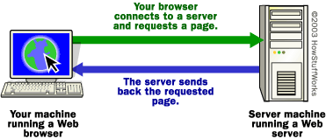

Your browser formed a connection to a Web server, requested a page and received it.

**Internal Process:**

If you want to get into a bit more detail on the process of getting a Web page onto your computer screen, here are the basic steps that occurred behind the scenes:

The browser broke the URL into three parts:

* The protocol ("http")
* The server name ("www.howstuffworks.com")
* The file name ("web-server.htm")

Firstly, the browser communicates with a [name server](http://computer.howstuffworks.com/dns.htm) to translate the server name "www.howstuffworks.com" into an IP Address, which it uses to connect to the server machine. The browser then formed a connection to the server at that IP address on port 80.

Following the HTTP protocol, the browser sent a GET request to the server, asking for the file "http://www.howstuffworks.com/web-server.htm."

The server then sent the [HTML text](http://computer.howstuffworks.com/web-page.htm) for the Web page to the browser. The browser read the [HTML tags](http://computer.howstuffworks.com/web-page.htm) and formatted the page onto your screen.

* **Static Webpages, Dynamic Web Pages & Web Applications**:

Static" means unchanged or constant, while "dynamic" means changing or lively. Therefore, static Web pages contain the same prebuilt content each time the pages loaded, while the content of dynamic Web pages can be generated on-the-fly. Standard HTML pages are static Web pages

**A Web-based application refers to any program that is accessed over a network connection using HTTP, rather than existing within a device's memory.** Web-based applications often run inside a Web browser. ... Web-based applications are also known as Web apps

* **HTTP- Hyper Text Transfer Protocol**:

The Hypertext Transfer Protocol (HTTP) is an [application protocol](https://en.wikipedia.org/wiki/Application_protocol) for **distributed, collaborative, and**[**hypermedia**](https://en.wikipedia.org/wiki/Hypermedia)**information** systems.

HTTP is the foundation of data communication for the [World Wide Web](https://en.wikipedia.org/wiki/World_Wide_Web).

[Hypertext](https://en.wikipedia.org/wiki/Hypertext) is structured text that uses logical links ([hyperlinks](https://en.wikipedia.org/wiki/Hyperlinks)) between [nodes](https://en.wikipedia.org/wiki/Node_(computer_science)) containing text. HTTP is the protocol to exchange or transfer hypertext

## HTTP Request Methods:

HTTP defines methods to indicate the desired action to be performed on the identified resource. HTTP (HyperText Transfer Protocol) is a request response protocol that runs on top of TCP

Its Responsibilities:

• Fetches pages from server to client

• Server usually runs on port 80

• Headers are given in readable ASCII

• Content is described with MIME types

• Protocol has support for pipelining requests

• Protocol has support for caching

* The HTTP/1.0 specification[[11]](https://en.wikipedia.org/wiki/Hypertext_Transfer_Protocol#cite_note-11) defined the GET, POST and HEAD methods
* The HTTP/1.1 specification[[12]](https://en.wikipedia.org/wiki/Hypertext_Transfer_Protocol#cite_note-12) added 5 new methods: OPTIONS, PUT, DELETE, TRACE and CONNECT.

Two commonly used methods for a request-response between a client and server are: GET and POST.

* **GET** - Requests data from a specified resource
* **POST** - Submits data to be processed to a specified resource

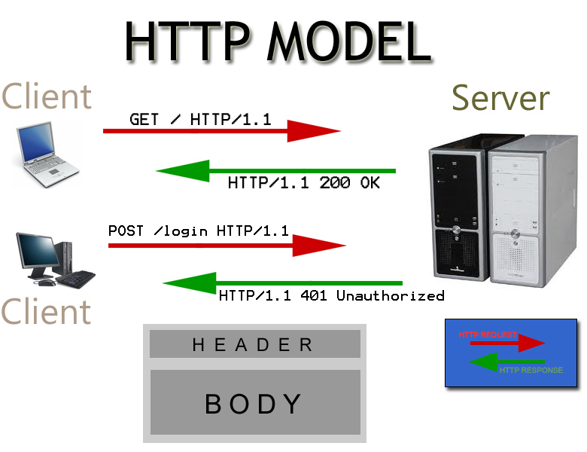

**The GET Method**

* GET requests can be cached
* GET requests remain in the browser history
* GET requests can be bookmarked
* GET requests should never be used when dealing with sensitive data
* GET requests have length restrictions
* GET requests should be used only to retrieve data

**Sample form using get method:**

<html>

<head><title> Sample form using get </title></head>

<body>

<form action=” “ method=”get”>

<input type=text name=”t1” placeholder=”Enter login”>

<input type=text name=”t2” placeholder=”Enter password”>

<input type=submit name=”s1” value=”SUBMIT”>

</form>

</body></html>

**The POST Method**

POST requests are never cached

POST requests do not remain in the browser history

POST requests cannot be bookmarked

POST requests have no restrictions on data length

**Sample form using Post method:**

<html>

<head><title> Sample form using get </title></head>

<body> <form action=” “ method=”post”>

<input type=text name=”t1” placeholder=”Enter login”>

<input type=text name=”t2” placeholder=”Enter password”>

<input type=submit name=”s1” value=”SUBMIT”>

</form>

</body></html>

**The Internet**

The Internet is a gigantic collection of millions of computers, all linked together on a **computer network**. The network allows all of the computers to communicate with one another. A **home computer** may be linked to the Internet using **a** [**phone-line modem**](http://computer.howstuffworks.com/modem.htm), [**DSL**](http://computer.howstuffworks.com/dsl.htm) **or** [**cable modem**](http://computer.howstuffworks.com/cable-modem.htm) **that talks to an Internet service provider (ISP)**. A computer in a **business** or university will usually have a **network interface card (NIC)** that directly connects it to a [**local area network**](http://computer.howstuffworks.com/lan-switch.htm) **(LAN**) inside the business. The business can then connect its LAN to an ISP using a high-speed phone line like a **T1 line**. A [T1 line](http://computer.howstuffworks.com/question372.htm) can handle approximately 1.5 million bits per second, while a normal phone line using a modem can typically handle 30,000 to 50,000 bits per second.

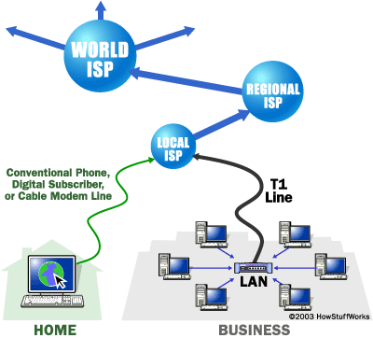

ISPs then connect to larger ISPs, and the largest ISPs maintain [fiber-optic](http://computer.howstuffworks.com/fiber-optic.htm) "backbones" for an entire nation or region. Backbones around the world are connected through fiber-optic lines, undersea cables or [satellite](http://science.howstuffworks.com/satellite.htm) links. In this way, every computer on the Internet is connected to every other computer on the Internet.

# Clients and Servers

In general, all of the machines on the Internet can be categorized as two types: servers and clients. Those machines that provide services (like Web servers or FTP servers) to other machines are **servers**. And the machines that are used to connect to those services are **clients**. When you connect to Yahoo! at www.yahoo.com to read a page, Yahoo! is providing a machine (probably a cluster of very large machines), for use on the Internet, to service your request. Yahoo! is providing a server. Your machine, on the other hand, is probably providing no services to anyone else on the Internet. Therefore, it is a user machine, also known as a client. It is possible and common for a machine to be both a server and a client, but for our purposes here you can think of most machines as one or the other.

A server machine may provide one or more services on the Internet. For example, a server machine might have software running on it that allows it to act as a Web server, an [e-mail](http://communication.howstuffworks.com/email.htm) server and an [FTP](http://www.webopedia.com/TERM/F/FTP.html) server. Clients that come to a server machine do so with a specific intent, so clients direct their requests to a specific software server running on the overall server machine. For example, if you are running a Web browser on your machine, it will most likely want to talk to the Web server on the server machine. Your [Telnet](http://www.webopedia.com/TERM/T/Telnet.html) application will want to talk to the Telnet server, your e-mail application will talk to the e-mail server, and so on...

**IP Addresses**

To keep all of these machines straight, **each machine on the Internet is assigned a unique address called an IP address**. IP stands for **Internet protocol**, and these addresses are [32-bit numbers](http://computer.howstuffworks.com/bytes.htm), normally expressed as **four "octets"** in a "**dotted decimal number.**" A typical IP address looks like this:

216.27.61.137

The four numbers in an IP address are called **octets** because they can have values between **0 and 255,** which **is 28** possibilities per octet.

Every machine on the Internet has a unique IP address. **A server has a static IP address** that does not change very often. A home machine that is dialling up through a modem often has an IP address that is assigned by the ISP when the machine dials in. That IP address is unique for that session -- it may be different the next time the machine dials in. This way, an ISP only needs one IP address for each modem it supports, rather than for each customer.